**Password Policy**

This SOP outlines the password policy for Store Managers (SM) in order to maintain secure access to the system. It provides instructions for setting, changing, and managing passwords, ensuring that they meet specific security requirements.

**Process Overview:**

The password policy for Store Managers (SM) is designed to enhance the security of access to the system. It covers password creation, changes, and management. Here are the step-by-step instructions:

* **Initial Login:**

**Step 1: Access the Email:**

- Start by opening your email client.

**Step 2: Select a Relevant Email:**

- Choose an email that contains your username and initial password.

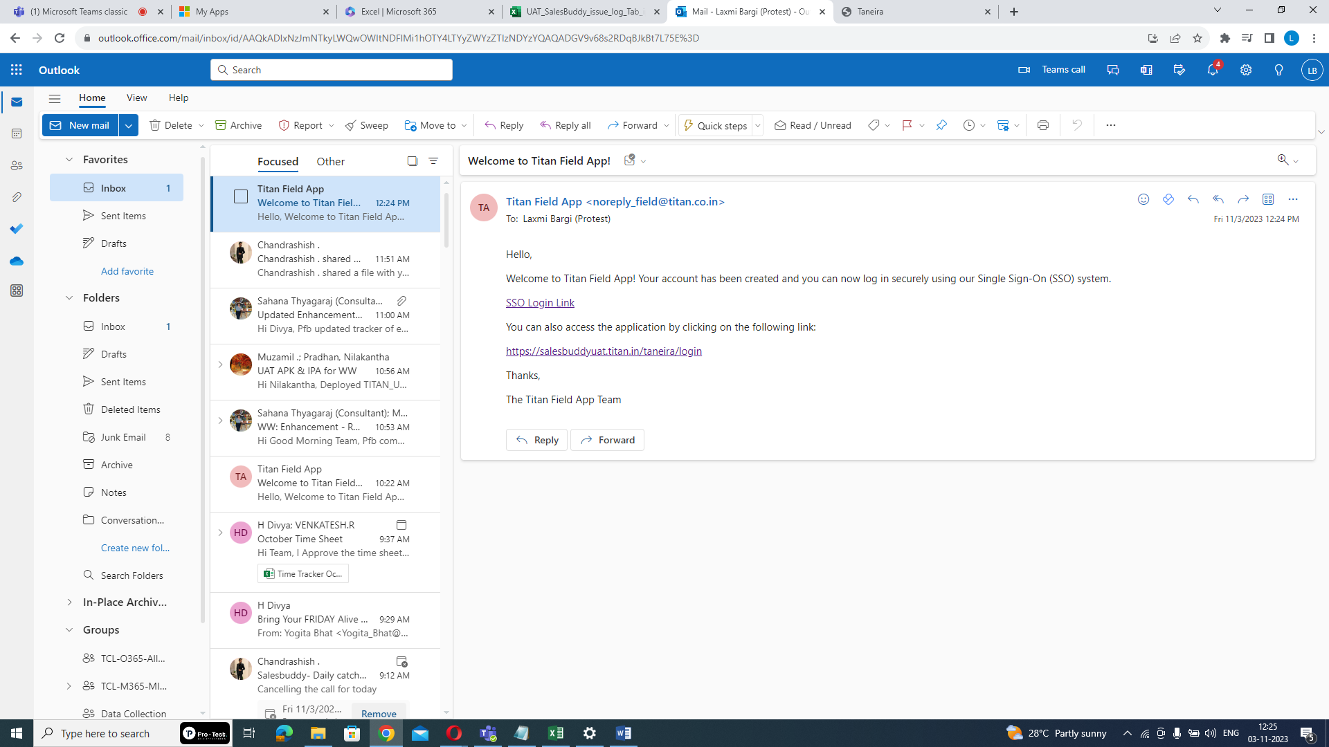

**Step3: Click on Login Link:**

- In the selected email, click on the provided login link. This link directs you to the login page.

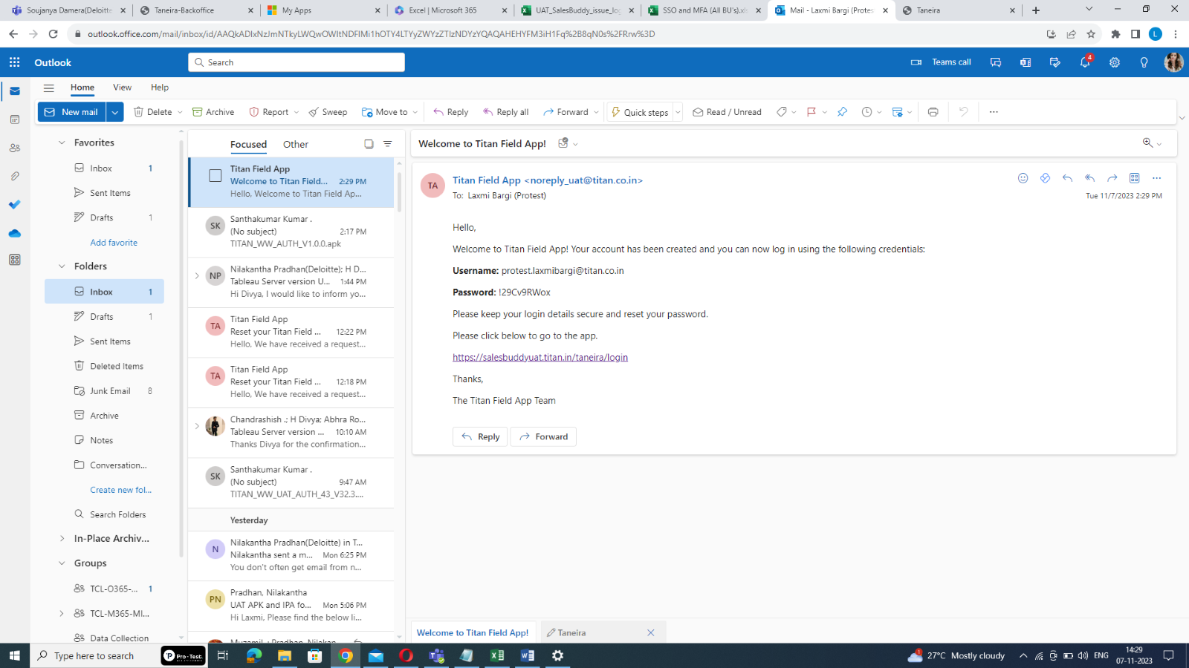  
**Step 4: Enter Email and Initial Password:**

Click here

Username and initial password

**-** Enter your email ID and the initial password sent to your registered email. (Note: The initial password must be changed after the first login.)

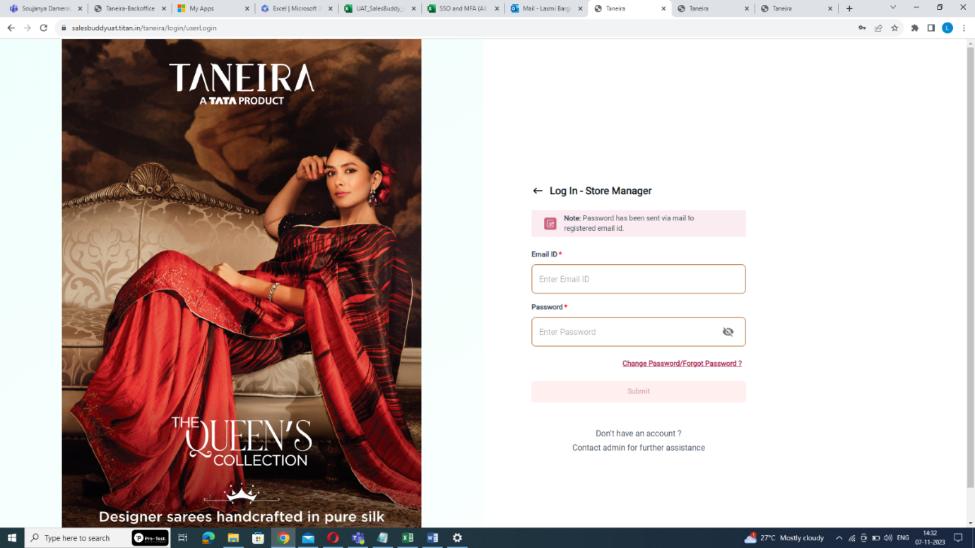

Enter email ID and initial password

**Step5: Click Submit:**

- After entering the initial password, click "Submit." The system will redirect you to the password reset page.

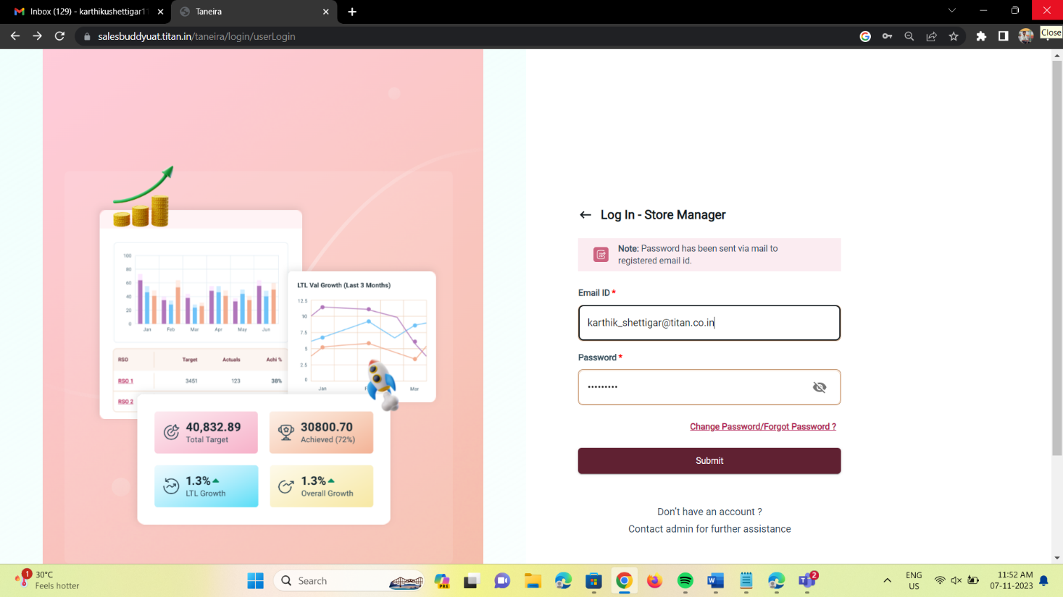

Click submit

**Step6: Reset the Password:**

- On the reset password page, create a new password. Ensure that it meets the following criteria:

* Password length must be at least 8 characters.
* At least 1 digit.
* At least 1 lowercase letter.
* At least 1 uppercase letter.
* At least 1 non-alphanumeric special character.

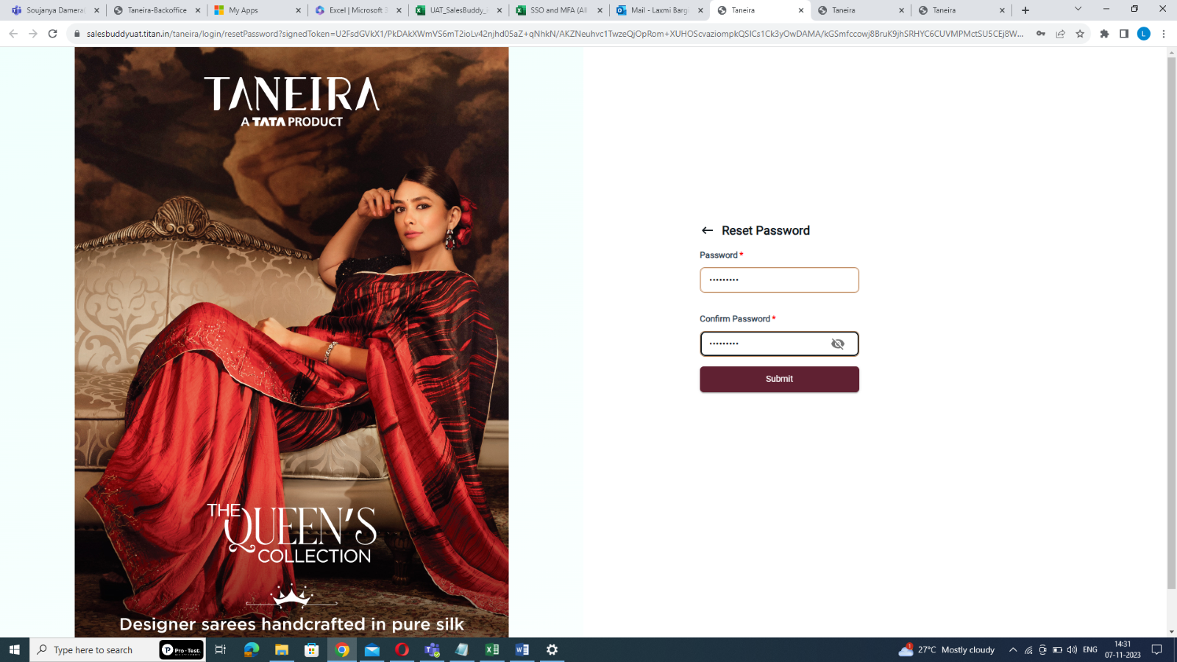

Enter password

**Step7: Confirm the Password:**

- Re-enter the newly created password for confirmation and Click "Submit".



Re-enter the password

**Step9: Click on Here:  
 -** To go back to the login page click “here”. It will redirect you to the login page.

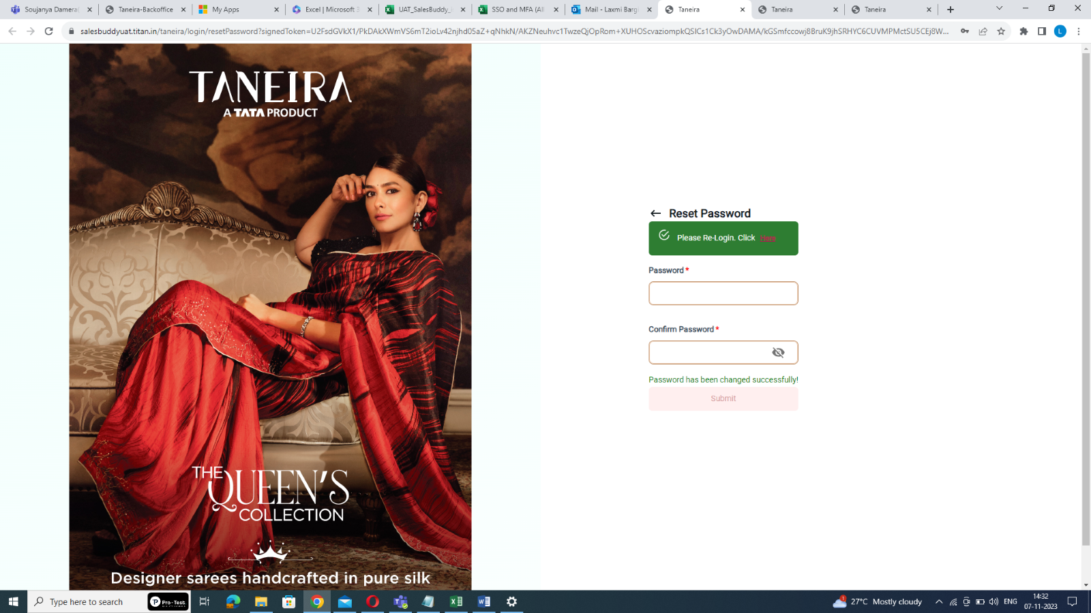

Click here

**Step9: Re-Login:**

- Re-login using your email ID and the newly created password.

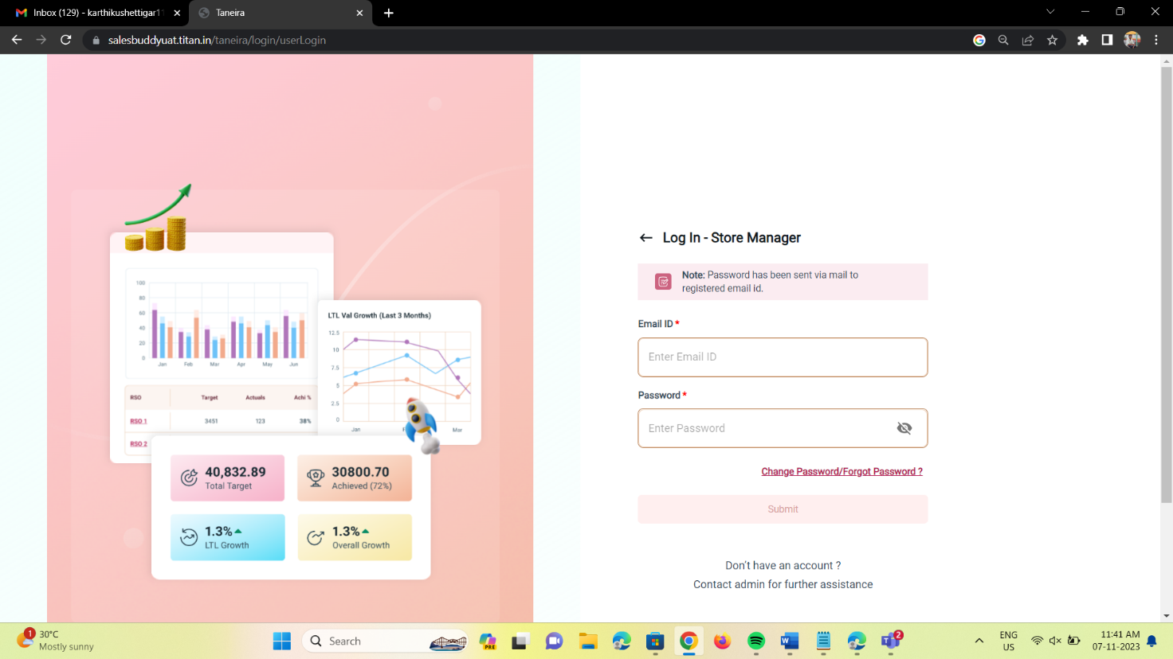

Enter email ID and password

**Step 8: Click submit:**

**-** Click "Submit" to login. Now you will be required to enroll in the Multi-Factor Authentication (MFA) process

Note: After 5 unsuccessful login attempts, the account will be locked for 15 minutes.

* **Change Password or Forget Password**

**Step1: Click Change Password/Forget Password?:**

- If you want to change your password or have forgotten it, Access the login page and click "Change Password/Forget Password?".



Click here

**Step2: Enter Email ID:**

- Enter your email ID on the provided page.

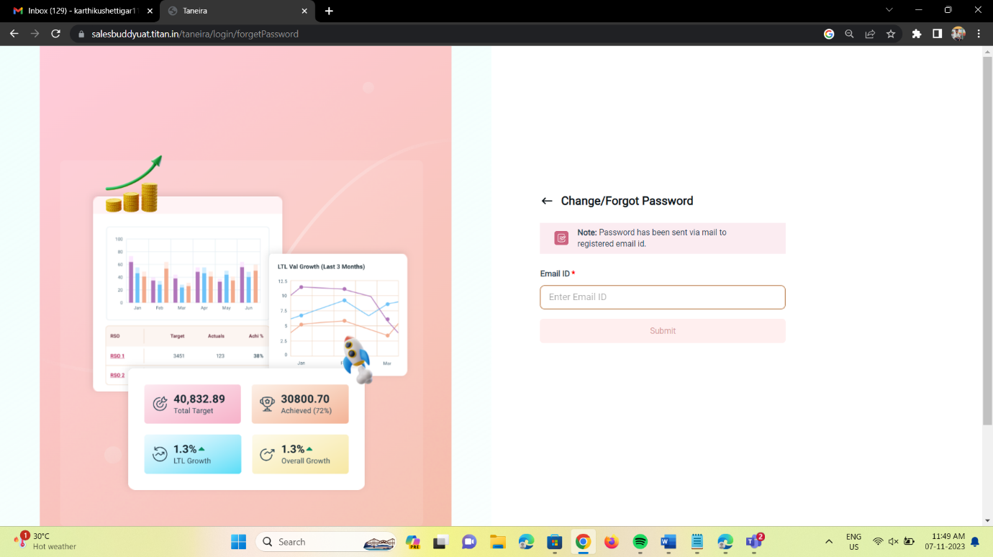

Enter email-id here

**Step3: Click Submit:**

- Click "Submit". A reset password link will be sent to your registered email.

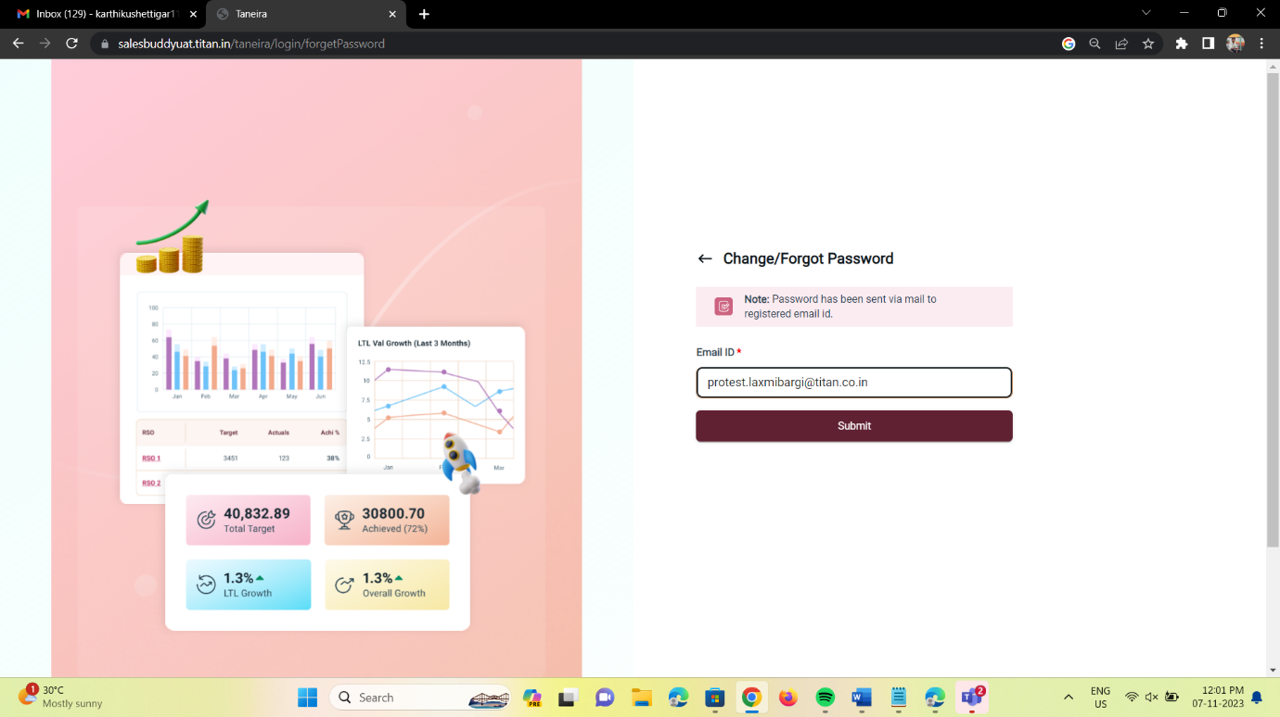

Click submit

**Step4: Access the Email:**

- Go to your email and select the relevant email containing the reset password link.

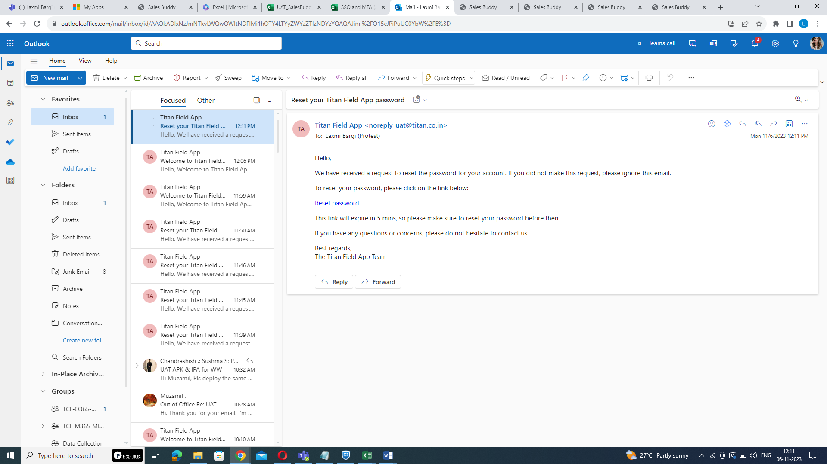

**Step5: Click on Reset Password Link:**

- Click on the provided reset password link. You will be redirected to the password reset page.



Click here



**Step6: Reset the Password:**

- On the reset password page, create a new password. Ensure that it meets the following criteria:

* Password length must be at least 8 characters.
* At least 1 digit.
* At least 1 lowercase letter.
* At least 1 uppercase letter.
* At least 1 non-alphanumeric special character.



Enter password

**Step7: Confirm the Password:**

- Re-enter the newly created password for confirmation and Click "Submit".



Re-enter the password

**Step9: Click on Here:**

**-** To go back to the login page click “here”. It will redirect you to the login page.



Click here

**Step9: Re-Login:**

- Re-login using your email ID and the newly created password.



Enter email ID and password

**Step 8: Click submit:**

- Click "Submit" to login. Now you will be required to enroll in the Multi-Factor Authentication (MFA) process

Note: After 5 unsuccessful login attempts, the account will be locked for 15 minutes.

* **Password Expiry:**

**Change Password Every 60 Days:**

**- Be aware that the system will automatically notify you to change your password after 60 days. This is an important security measure.**

By following these step-by-step instructions, Store Managers can ensure their passwords meet the security requirements and maintain a secure access policy in accordance with the organization's guidelines.